

12 PHYSICS

WAVE-PARTICLE DUALITY &

QUANTUM THEORY

ELECTROMAGNETIC SPECTRUM

The English physicist James Clerk Maxwell proposed that if a changing electric field is produced, for example by a charged particle moving backwards and forwards, then this changing electric field will produce a changing magnetic field at right angles to it. The changing magnetic field would, in turn, produce a changing electric field and the cycle would be repeated.

Any vibrating or oscillating electric charge will produce oscillating electric and magnetic fields that are at right angles to each other. It is these fields spreading at the speed of light that we call electromagnetic radiation.

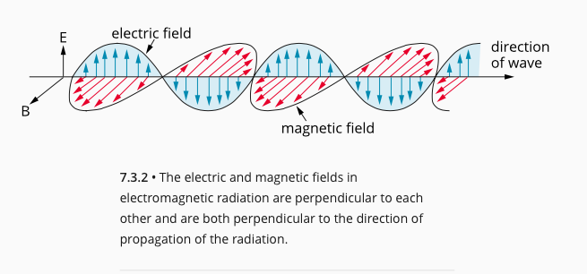

The source of the electromagnetic radiation is usually an oscillating electric charge.

The Electromagnetic Spectrum

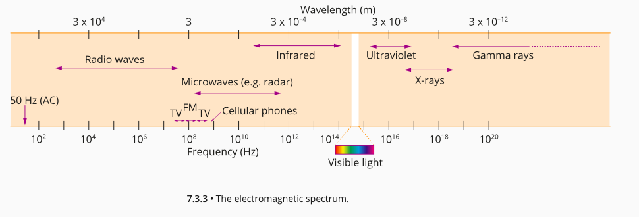

1. Power Frequencies

• Produced by alternating current (AC) generators.
• Emitted by generators and transmission lines.

2. Radio Waves

• Emitted by electrons which are forced to undergo oscillations in a wire.
• The frequency of oscillation governs the frequency of the radio waves.
• If radio waves intercept a conductor of appropriate length (1/2 of the wavelength of the
wave) they start electrons in the conductor oscillating at the same frequency. This is the
basis of an aerial or antennae.

3. Microwaves

• Generated in magnetrons and klystron tubes where electrons are made to resonate in a
small cavity.
• Used in radar, communications and microwave ovens.

4. Infra-Red

• Produced by excited outer electrons in atoms and molecules returning to their ground
state.
• Felt as heat on the skin.

5. Visible

• Produced as per infra-red.
• Allows animals to see objects.

6. Ultra-Violet

• Produced as per infra-red.
• Produces tanning/skin cancers in humans, allows plants to photosynthesise, important in
the formation of photochemical smog.

7. X-Rays

• Produced by rapidly decelerating electrons after hitting a metal target, as well as inner
electrons of atoms returning to their ground state.
• Useful for diagnosis of medical problems inside the body.

8. Gamma Rays

• Produced by the oscillation or acceleration of charges within the nuclei of atoms.
• Useful in industry to detect problems with structures involving steel and concrete.

Dual Nature Of Light

The present theory of light is a mixture of two competing theories - the electromagnetic theory (where light shows wave-like properties) and the quantum theory (where light shows particle-like properties).

Electromagnetic Theory

Light can be reflected, refracted and diffracted just like water waves, hence it was (before 1900) considered wave-like.

• See Ch. 7.1 of Physics Western Australia 12 and review the following.

• Huygen's Principle - role of secondary wavelets.
• Reflection and refraction.
• Diffraction and interference.

• Revise any notes from Year 11 on this section.

Quantum Theory

This explained other observed phenomena such as the photoelectric effect.

Electrons can be removed from certain metallic substances by light. To do this, the light is thought to be made up of “packets” or “quanta” of energy called photons.

Thus it appears light is made up of “particles”.

It is accepted by scientists that light behaves as waves or particles, depending on the experiment being performed.

EVIDENCE SUPPORTING ELECTROMAGNETIC THEORY

(See Ch. 7.1 of Physics Western Australia 12.)

Young's Double-slit Experiment

Between the 17th and 19th centuries, most scientists considered light to be a stream of particles. This idea was based on the 'corpuscular' theory proposed by Sir Isaac Newton.

In 1803, an English scientist called Thomas Young performed an experiment in which he shone monochromatic light on a screen containing two very tiny pinholes. On the far side of the double-pinhole screen, he placed another screen on which he observed the pattern produced by the light passing through the pinholes.

According to the particle theory, light should have passed directly through the pinholes to produce two bright spots on the screen.
Instead, Young observed a series of bright and dark fringes.
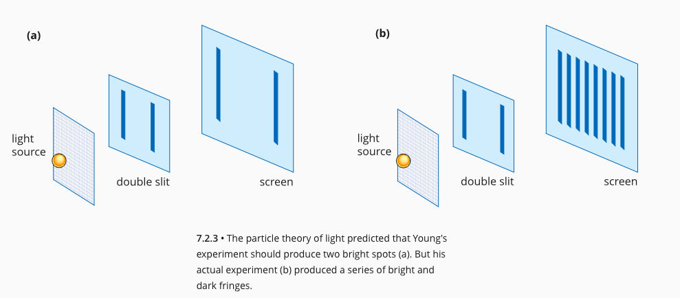

Young was able to explain this pattern by treating light as a wave. He assumed that the monochromatic light was like plane waves and that, as they passed through the narrow slits, these plane waves were diffracted into circular waves as shown below.

The interference pattern produced by these two waves would result in lines of constructive (antinodal) and destructive (nodal) interference that would match the bright and dark fringes respectively.

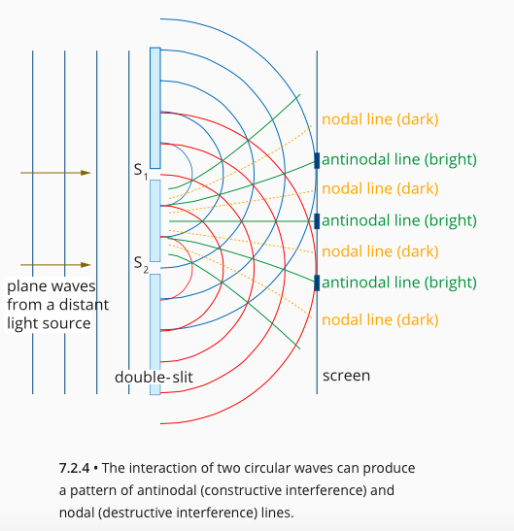

EVIDENCE SUPPORTING QUANTUM THEORY

(See Ch. 7.4 of Physics Western Australia 12.)

At the turn of the of the 20th century, a number of scientists turned their attention to phenomena such as black-body radiation and the photoelectric effect that could not be readily explained using Maxwell's electromagnetic wave model. The study of these phenomena required the development of much more sophisticated models for light and eventually led to a revolution in our understanding of the nature of energy and matter.

Black-body Radiation

All objects that have temperatures above absolute zero emit electromagnetic radiation. For objects at room temperature, practically all of this radiation is emitted in the infrared part of the electromagnetic spectrum, which is not visible to the human eye.

At higher temperatures, not only is the total amount of radiation emitted larger, but also a higher proportion of it is in the visible part of the spectrum.

• Around 3000 K - a significant amount of energy is emitted as red wavelengths of the visible spectrum and the object appears 'red hot'.
• Around 6000 K - energy is radiated roughly evenly across different wavelengths of the visible spectrum so the object appears 'white hot'.
• Around 12000 K - more of the energy is being radiated in the ultraviolet and violet parts of the spectrum, so the object appears 'blue hot', like the hottest flame of a Bunsen burner.

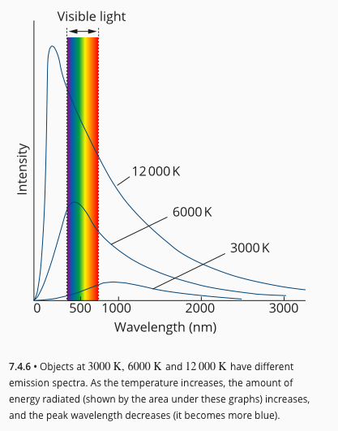

A black-body is an ideal absorber and absorbs all incident radiation; it is in equilibrium with its surroundings, as it radiates and absorbs energy at the same rate, and so its temperature remains constant.

A blackbody can be approximated by the inside of a cavity with a small entrance hole, because all light entering the hole is trapped.

The shape of the radiation spectrum only depends on the temperature of the black-body, not its colour.

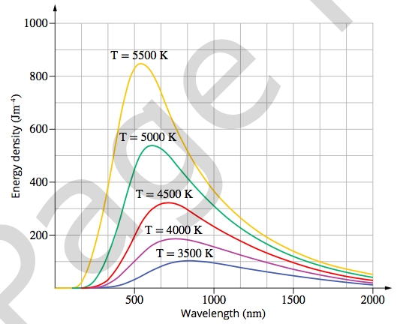

As the temperature increases, the peak in energy density increases and the total energy emitted (represented by the area under the curve) by the object increases.

In addition, the peak wavelength (λ_{max}) decreases; this corresponds to an increase in peak frequency and energy.

This shift to shorter wavelengths was found to have the following relationship, known as Wien’s Displacement Law.

λ_{max}T = 0.2898 × 10^{–2} mK

where T = the temperature in kelvin (K)
λ_{max} = the wavelength (m)

Classically, thermal radiation is emitted by accelerating charges near the surface of a material. The charges have a distribution of accelerations that leads to a range of thermal energies.

The classical expression, known as the Rayleigh–Jeans Law, gives the average energy per oscillating or vibrating charge proportional to temperature.

The radiated energy can be considered to be produced by standing waves or resonant modes within the cavity.
At long wavelengths (λ), there is a reasonable agreement between the experimental data and the calculation.

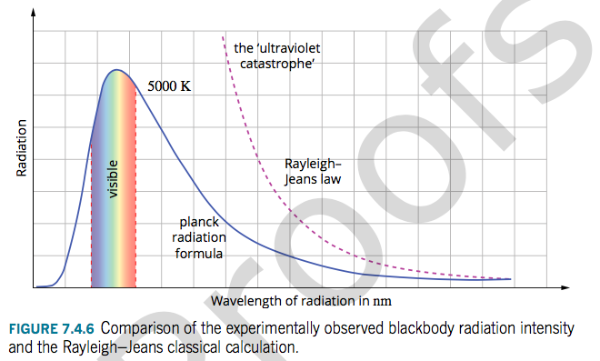

However, as the wavelength gets shorter (frequency increases), the number of modes gets significantly larger and the energy density increases and approaches infinity. This is known as the ultraviolet catastrophe.

Although scientists had developed equations to explain the total amount of energy emitted by a black-body and the wavelength peak of the emission spectrum, these could not be adequately explained using the wave model of light.

Planck's equation

In 1900, the German physicist Max Planck was studying the spectrum for light emitted by a black-body when he realised that the shape of the spectrum resembled a statistical distribution curve, like the normal distribution curve used to study random samples of populations.

In order for the theory to fit experimental observations, Planck incorporated two fundamental postulates.

1. Molecules vibrate at discrete energies or frequencies, as show below.

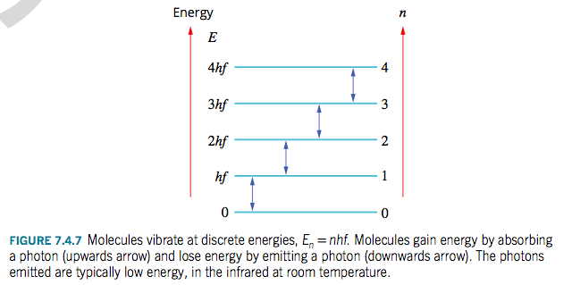

2. Molecules absorb and emit radiation in in discrete packets called photons, and the energy of an individual photon is E = hf.

Using this insight, Planck was able to show that if he assumed light was emitted as discrete packets, each with an energy proportional to its frequency, then he could exactly predict the black-body emission spectrum.

Planck called the discrete packets of energy quanta and developed an equation for the energy
of each quantum:

E = hf

where f = the frequency of the electromagnetic radiation (Hz)
h = Planck's constant (= 6.63 × 10⁻³⁴ Js)

Since electromagnetic radiation is more commonly described according to its wavelength, scientists often combine Planck's equation with the wave equation c = fλ as follows.

Photoelectric Effect

Another phenomenon that could not be explained using the wave model for light was known as the photoelectric effect.

Scientists noticed that when some types of electromagnetic radiation shine on a piece of metal, the metal becomes positively charged. This positive charge is due to electrons being ejected from the surface of the metal. The electrons became known as photoelectrons because they were released due to light or other forms of electromagnetic radiation.

A common apparatus used to observe the photoelectric effect is shown in the figure below. A clean metal surface (the cathode) is illuminated with light from an external source. If the light causes photoelectrons to be emitted, they are detected at the anode. The flow of electrons is called the photoelectric current and is registered by a sensitive ammeter.

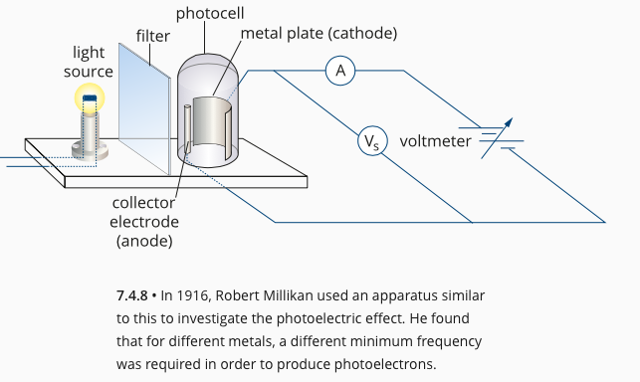

The circuit includes a variable voltage supply, which can be used to make the cathode negative (and the anode positive). When this is done, the photoelectrons will be helped by the resulting electric field to the anode, and a maximum possible current will be measured.

Alternatively, the voltage may be adjusted to make the cathode positive and the anode negative.

The German physicist Philipp Lenard made a number of surprising discoveries about the photoelectric effect. Lenard used the filter to vary the frequency of the incident light. He discovered:
• For a particular cathode metal, there is a certain frequency below which no photoelectrons are observed. This frequency is called the threshold frequency f_{o}.

• For frequencies of light greater than the threshold frequency (i.e. f > f_{o}),
photoelectrons will be collected at the anode and registered as a photoelectric current.

• For frequencies below the threshold frequency (i.e. f < fo), no photoelectrons will be detected.

Lenard also discovered that, for light whose frequency is greater than the threshold frequency
(f > f_{o)} , the rate at which the photoelectrons are produced varies in proportion with the intensity of the incident light as shown in the graph below.

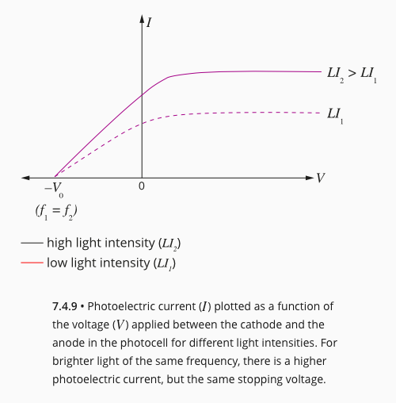

This graph shows a number of important features of the photoelectric effect.

• When the light intensity increases, the amount of photoelectric current increases.

• When the applied voltage is positive, photoelectrons are attracted to the collector electrode. A small positive voltage is enough to ensure that every available photoelectron is collected and the current reaches its maximum value.

• When the applied voltage is negative, photoelectrons are repelled by the collector electrode and the photoelectric current is reduced.

There is a voltage, -V_{o}, for which no photoelectrons reach the collector. This is known as the stopping voltage. For a particular frequency of light on a particular metal, this stopping voltage is a constant.

When light sources of the same intensity but different frequencies are used, they produce the same maximum current, but the higher frequency light has a higher stopping voltage (see figure below).

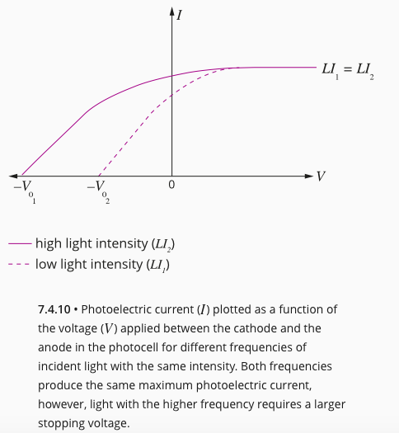

The stopping voltage V₀ is used to calculate the maximum E_{k} of the photoelectrons. To overcome the potential difference equal to the braking voltage, an electron needs to perform work W equal to the product of the voltage V and the charge of an electron q.

i.e. W = E_{k} _{(max)} = V_{o} q

Finally, as long as the incident light has a frequency above the threshold frequency of the cathode material, photoelectrons are found to be emitted without any appreciable time delay. This fact holds true regardless of the intensity of the light.

Explaining The Photoelectric Effect

The characteristics of the photoelectric effect could not be easily explained using a wave model of light.

According to the wave model, the frequency of light should be irrelevant to whether or not photoelectrons are ejected. Since a wave is a form of continuous energy transfer, we would expect that even low frequency light should transfer enough energy to emit photoelectrons if left to shine on the metal for long enough.

Similarly, the wave model predicted that there should be a time delay between the light striking the metal and photoelectrons being emitted as the energy from the wave built up in the metal. There is no delay in the photoelectrons being emitted.

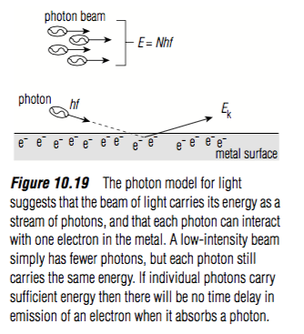
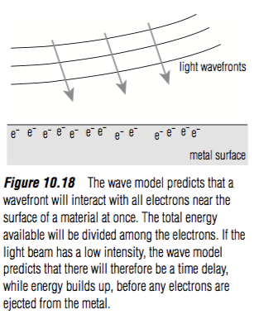

In 1905, Albert Einstein proposed a solution to this problem. Einstein drew on Planck's earlier work on black-body radiation by assuming that light exists as particles, or 'photons' (like Planck's 'quanta'), each with an energy of E=hf. This assumption made the properties of the photoelectric effect relatively easy to explain.

Einstein identified that, for a particular metal, the amount of energy required to produce a photoelectron is a constant value that depends on the strength of the bonding within the metal. This energy was called the work function (W) of the metal.

e.g. The work function of lead is 4.25 eV, which means that 4.25 eV of energy is needed to release one electron from the surface of a piece of lead.

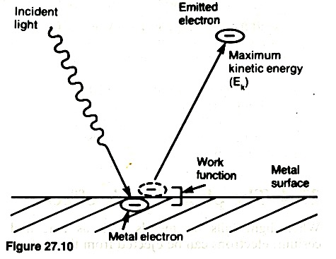

Example

If the energy of the photon is less than the work function W, then photoelectrons will not be released.

The photons of violet light (f = 7.5 x 10¹⁴ Hz) each contain 3.1 eV of energy.

E = hf
= (6.63 x 10⁻³⁴)(7.5 x 10¹⁴)
= 5.0 x 10⁻¹⁹ J
= 3.1 eV

This means that violet light shining on lead would not produce photoelectrons since the energy of each photon is less than the work function of lead.

This explains why each metal has a threshold frequency - this is the frequency at which the photons have an energy equal to the work function of the metal.

W = hf_{o}

If the energy of the photon is greater than the work function of the metal, then a photoelectron is released. Any excess energy in the photon is transformed into the kinetic energy of the photoelectron.

Einstein described this relationship with his photoelectric equation:

E_{k} = hf - W

where E_{k} = kinetic energy of the photoelectron (J)
h = Planck's constant (= 6.63 x 10⁻³⁴ Js)
f = the frequency of the incident light (Hz)
W = work function (J)

The graphs below show the photoelectric behaviour of different metals. Note the following.

• The gradient is constant for each metal (with a value of Planck's constant h).
• They have different threshold frequencies.

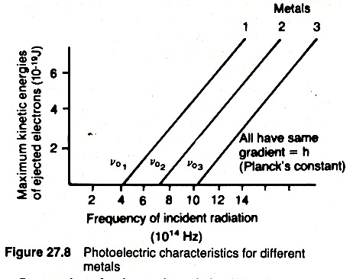

By extrapolating the graphs backwards, it is possible to gain some information about the value of the work function W. In the following diagram, E_{k} values are in eV.

e.g. W (for Mg) = 3.5 eV

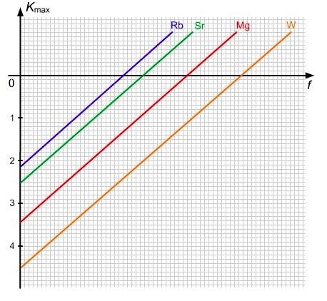

Example

Note - φ is used instead of W for work function.

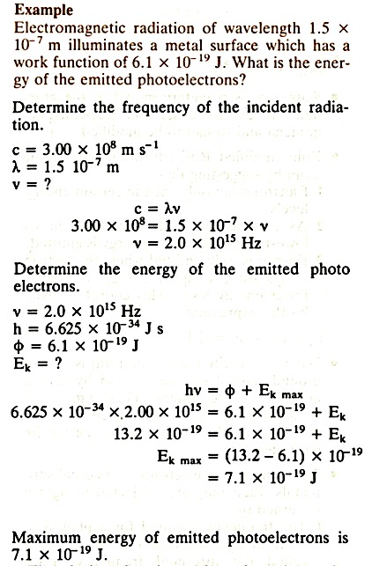

THE STRUCTURE OF ATOMS

(See Ch. 7.5 of Physics Western Australia 12.)

The Bohr Model

This model was used to improve an earlier attempt at describing an atom by Rutherford.

The Bohr model is based on the following ideas.

1. Electrons, which orbit the nucleus, can only have certain energies and move around in
“energy levels”. These levels are given numbers, the lowest level given number 1.

2. Electrons can only have the energy of the energy level that it was in.
i.e. Only particular energy levels are possible.

3. Photons of energy are emitted as an electron moves from a higher energy level to a
lower energy level.

At normal temperatures, electrons will fill the lowest energy levels possible. This is the ground state of an atom.

Bohr devised an equation that gives each of the energy levels in the hydrogen atom.

where n = the number of the energy level.

The value 13.6 eV is the ionisation energy of a hydrogen atom.

i.e. The energy required to totally remove an electron from the atom.

The energy is negative because it is necessary to add energy to the electron to free it from the atom.

A free electron from an atom is arbitrarily given an energy value of zero.

PRODUCTION OF LINE SPECTRA

If energy is absorbed by the atom (either by heating, absorption of electromagnetic radiation or bombardment by electrons), one or more electrons can be moved into a higher energy level. The atom is now called an excited atom.

The amount of energy absorbed by the electrons in the atom is equal exactly to the energy levels above ground state.

When the excited electrons move back to the lower energy levels, they give off an equivalent amount of energy as photons of electromagnetic radiation (visible light, UV radiation, IR radiation, X -rays, gamma rays).

When returning from higher energy levels, the electrons can transition back in one step or in several steps, releasing photons of differing frequencies.

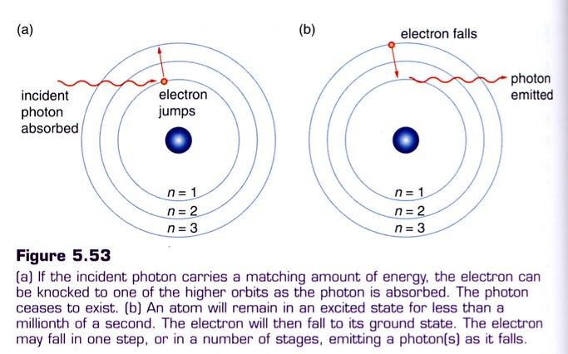

Example

Consider the energy levels of the hydrogen atom.

The particular wavelength and frequency of the radiation depends on the two particular energy levels involved.

The energy involved in the transition is given by:

where E_{photon} = the energy released by the electron as it transitions back to
its ground level (J)
E₂ = the upper energy level (J)
E₁ = the lower energy level (J)
h = Planck’s constant = 6.62 x 10⁻³⁴ Js
f = the frequency of the light emitted (Hz)
c = speed of light (ms⁻¹)
λ = wavelength of the emitted photon of light (m)

Each of the emitted frequencies of light will correspond to a particular line in the spectral lines for the atom.

Example 1

An electron in an excited hydrogen atom drops from the third energy level (- 1.51 eV) to the second energy level (- 3.40 eV). Calculate the wavelength of the emitted photon.

Note 1.00 eV = 1.60 x 10-19 J

Example 2

Five series of line spectra have been identified in the spectrum from an excited hydrogen atom. Three of these are the Lyman, Balmer and Paschen series.

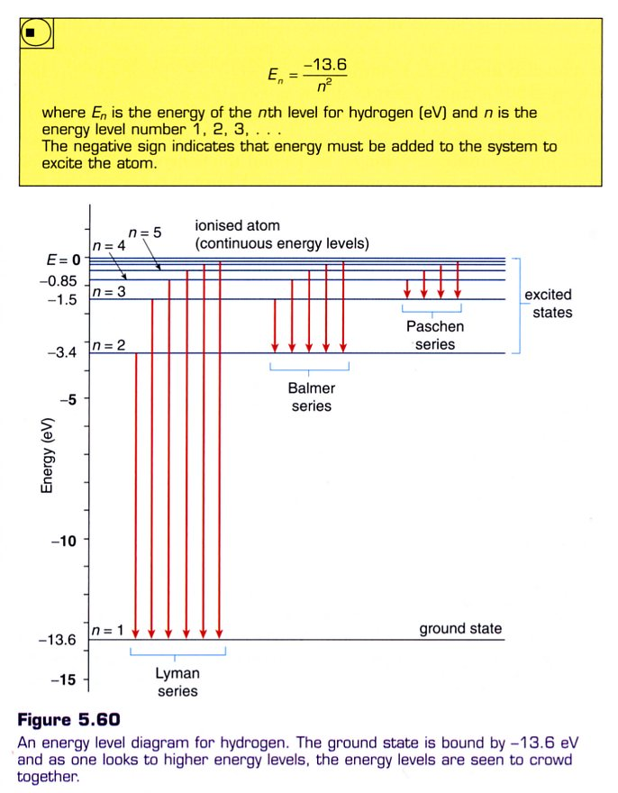

From E = hf, the larger the energy transition, the larger the frequency of the emitted light. This corresponds to the UV end of the spectrum.

∴ Lyman series is in the UV range,
Balmer series is in the visible range
and the Paschen series is in the IR
range.

Example 3

A gas atom has the following energy levels - E₁ = -3.10 x 10⁻¹⁸ J, E₂ = -1.79 x 10⁻¹⁸ J,
E₃ = -1.16 x 10⁻¹⁸ J, E₄ = -0.99 x 10⁻¹⁸ J. A sample of the gas is bombarded by a stream of electrons with energies of 2.25 x 10⁻¹⁸ J.

(a) Will the bombarding electrons be able to ionise the gas atoms? Explain.
(b) What will be the energy of the emitted photons?
(c) What will be the energy of the scattered electrons?

(a) The bombarding electrons have enough energy to reach the fourth energy level but not
enough to reach the ionisation level.

(b) Having reached the fourth energy level, there are six possible energy transitions.

E₄ - E₁ = 2.11 X 10⁻¹⁸ J E₃ - E₁ = 1.94 x 10⁻¹⁸ J

E₂ - E₁ = 1.31 x 10⁻¹⁸ J E₄ - E₂ = (2.11 - 1.31) x 10⁻¹⁸
= 0.80 x 10⁻¹⁸ J

E₃ - E₂ = (1.94 - 1.31) x 10⁻¹⁸ E₄ - E₃ = (2.11 - 1.94) x 10⁻¹⁸
= 0.63 x 10⁻¹⁸ J = 0.17 x 10⁻¹⁸ J

(c) The bombarding electrons will only lose an amount of energy equal to one of the energy
levels of the gas atom, not an amount equal to the difference between energy levels.

i.e. The absorbed energies will be 1.31 x 10⁻¹⁸ J, 1.94 x 10⁻¹⁸ J, 2.11 x 10⁻¹⁸ J.

∴ Scattered energies will be as follows.

2.25 x 10⁻¹⁸ J (electrons go through the gas without hitting an atom)

(2.25 - 1.31) x 10⁻¹⁸ = 0.94 x 10⁻¹⁸ J

(2.25 - 1.94) x 10⁻¹⁸ = 0.31 x 10⁻¹⁸ J

(2.25 - 2.11) x 10⁻¹⁸ = 0.14 x 10⁻¹⁸ J

Example 4
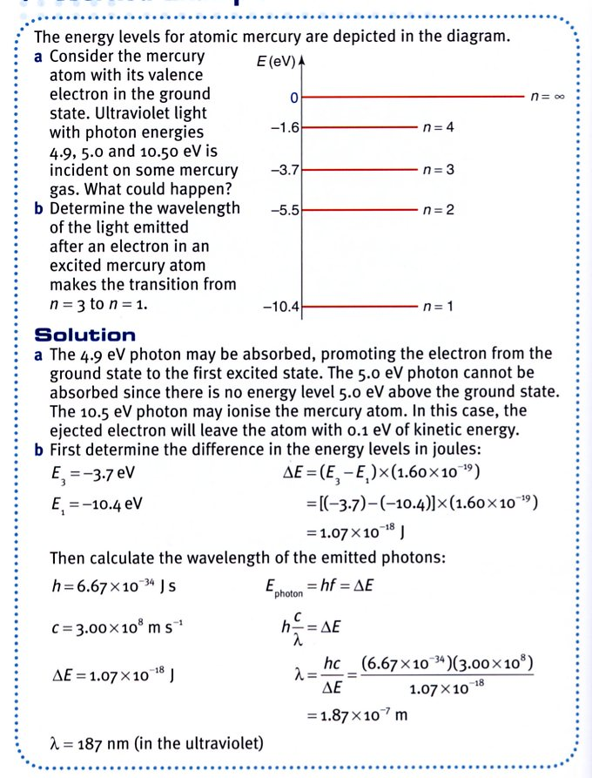

Example 5

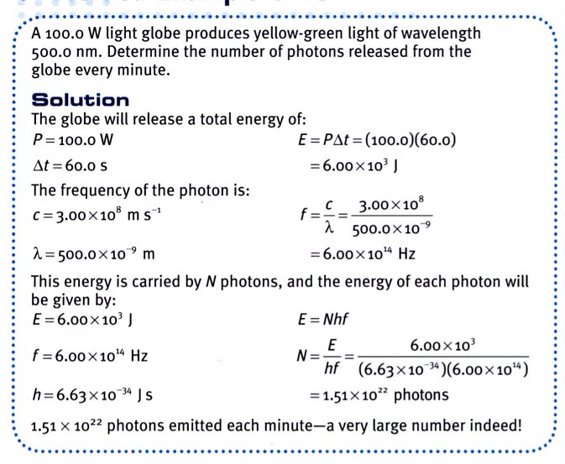

Light-emitting Diodes (LEDs)

A light-emitting diode (LED) is a semi-conducting device that uses the excitation of electrons to produce light. LEDs are made from a variety of semiconductors, including GaAs, CdS, silicon and GaN-based materials. The addition of a small amount of another material, in a process known as ‘doping’, can change the conductive properties of semiconductors.

In a semiconductor diode, most of the electrons sit in an energy band known as the valence band. At a slightly higher energy is another energy band, known as the conduction band.

If a small amount of electrical energy is provided as a potential difference, electrons can jump from the valence band to the conduction band and then move through the semi-conductor as an electric current. When the electrons eventually drop back into the valence band, their energy is released as photons.

The difference in energy between the conduction band and the valence band level is known as the band gap, E_{g}.

To turn on a basic LED, a potential difference or voltage needs to be applied. The threshold voltage, V_{th}, or potential difference required, is approximately equivalent to the band gap, E_{g}, or difference in the two energy levels of the emitting photons.

The colour or wavelength (λ) of the light produced is determined by the energy gap between the valence and conduction bands.

An approximate relationship can be given by:

$$V_{th}q = \frac{hc}{} = E_{g}$$

Measuring the threshold voltage for a series of LEDs can give an approximate measure of the band gap and emitting wavelength.

If the wavelength or frequency of the LED is known, then V_{th} can be plotted versus f. Comparing this to an equation of a straight line, y = mx + c, it can be seen that the slope of the line is hq . Knowing q, the electron charge, a value for h can be determined.

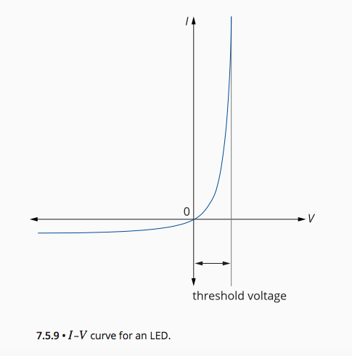

Limitations to Bohr's Model

• Bohr’s Model can only be used to explain the spectral lines observed in the hydrogen atom.

• It fails to explain the emitted spectral lines of any other gas.

Quantum mechanics, a complex mathematical model developed by scientists (de Broglie, Schrodinger, Heisenberg), accounted for the results of experimental studies. It is based on the theory that particles have some wave characteristics, just as waves exhibit certain particle characteristics.

(See Ch. 7.6 of Physics Western Australia 12.)

In 1924, Louis de Broglie proposed a ground-breaking theory. He suggested that since light, which had long been considered to be a wave, sometimes demonstrated particle-like properties, then perhaps matter, which was considered to be made up of particles, might sometimes demonstrate wave-like properties.

He quantified this theory by predicting that the wavelength of a particle would be given by the equation:

where p = the momentum of the particle (kgms⁻¹)
h = Planck's constant (= 6.63 x 10⁻³⁴ Js)

This is also commonly written as:

where m = the mass of the particle (kg)
v = the velocity of the particle (ms⁻¹)

De Broglie's prediction was confirmed by the Americans Davisson and Germer in 1927 when they observed diffraction patterns being produced in an experiment where they bombarded the surface of a piece of nickel with electrons.

The quantum nature of matter
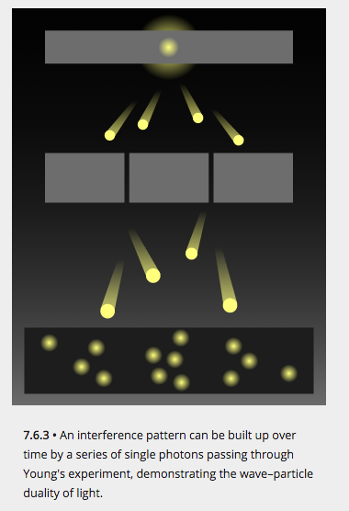
The quantum model of light (energy) was extended to matter. It led to a fundamental shift in the way we view the universe around us.

In the early years of quantum theory, some scientists believed that the wave properties of light observed in Young's double slit experiment may have been due to some sort of interaction between photons as they passed through the slits together.

Experiments were done with light sources that were so dim that scientists were confident that only one photon was passing through the apparatus at a time. These experiments produced identical interference patterns to those done with bright sources.

Interestingly, when a detector is used to measure which slit the photon passes through, the wave pattern disappears and the photon acts like a particle.

Matter Waves And The Bohr Atom

De Broglie's work allowed one of the great mysteries of the atom to be solved. In the previous Rutherford model of the atom, an electron orbiting the nucleus of an atom should radiate energy and spiral inwards. But this was not observed, and scientists could not explain why not.

In formulating his model of the hydrogen atom, Bohr made an assumption that if an electron of mass m were moving with velocity v in an orbit with radius r, this orbit would be stable if it matched the condition:

where n = an integer

This can be rearranged to:

Since 2πr is the circumference C of a circle and by the de Broglie equation , this equation can be rewritten as:

In other words, the stable orbits of the hydrogen atom are those where the circumference is exactly equal to a whole number of electron wavelengths. An electron orbiting an atom is a type of electron standing wave.

This can be visualised by imagining a conventional standing wave pattern, like in a vibrating string, being looped around on itself as shown in the figure below.

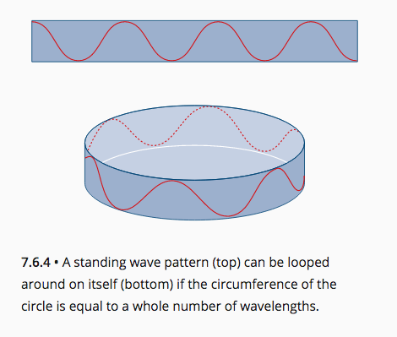

Erwin Schrödinger developed a mathematical equation that describes the wave behaviour of electrons. The wave properties of electrons are interpreted as representing the probability of finding an electron in a certain location.

Quantum mechanics is the name now given to the area of physics in which the wave properties of electrons are studied. Schrödinger's equation has been used to calculate the regions of space in which an electron can be found in a hydrogen atom. These are now known as 'orbitals' rather than orbits because they are complex three-dimensional shapes, rather than the simple circular paths once imagined by Rutherford and Bohr.

Heisenberg's uncertainty principle

There are some quantities that are impossible to measure precisely. The first scientist to clearly identify this was the German physicist Werner Heisenberg. Heisenberg's uncertainty principle describes a limit to which some quantities can be measured.

For example, imagine we are trying to measure the exact location of an electron. The only way to do this would be to hit the electron with another particle such as a photon of light. However, as soon as the photon strikes the electron, it would cause the electron to move. In this way, the act of measurement causes a change in the value being measured. This is a general problem when trying to measure the location or motion of sub-atomic particles.

Scientists still argue about the interpretation of this equation, whether it means there is a fundamental 'fuzziness' to the universe, or if this just represents the limit of our ability to measure.

CLASSIFICATION OF SPECTRA

(See Ch. 7.5 of Physics Western Australia 12.)

There are two classes of spectra - emission and absorption spectra.

Emission spectra are obtained by the dispersion of light coming directly from a source due to its bombardment by electrons or by heating.

Absorption spectra occur when light is passed through an absorbing material.

Emission Spectra

1. Line Emission Spectra

These are produced by emissions from gases under low or normal pressures.

The spectrum is a number of single, sharply-defined lines on a dark background.

Each element has its own characteristic line spectrum. It is due to this that line emission
spectra can be used to identify the constituents of unknown substances.

2. Band Emission

These are produced by excited molecules in the gaseous state. Molecules have many more
energy levels than atoms and the energy levels are in close groups.

The spectrum is made up of bands with a sharp edge and a diffuse edge on a dark background.

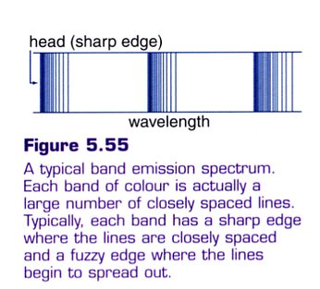
It is actually made up of a group of lines that come closer
together as they approach the sharp edge of the band.

Bands are present in the emission spectra produced from
flames.

Around the flame is a thin layer of gas (called a mantle)
which contains combustion products such as CO and
H₂O.

It is these molecules, excited by the heat of the
flame, that account for bands in the emission spectra.

3. Continuous Emission Spectra

These spectra consist of all colours from red at one end to violet at the other, as all
wavelengths of light are present.

This spectrum is produced by incandescent solids such as the tungsten filament in a light
globe, or hot liquids such as molten iron in a smelter.

This type of radiation is called black-body radiation and the specific characteristics of the
continuous spectrum depends on the temperature of the emitting solid or liquid.

At a temperature of around 1000 °K, a solid will glow ‘red hot’. The filaments of light globes
operate at around 3000 °K and glow ‘white hot’. The light from incandescent light globes is
rich in orange, red and infrared.

At around 6000 °K a black body emits a spectrum very much like the spectrum of the Sun.
Sunlight is mainly red, orange and yellow.

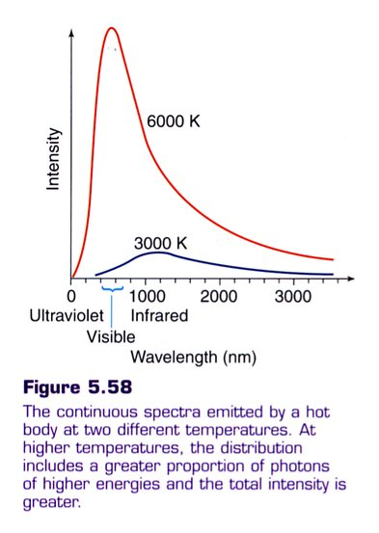

Absorption Spectra

1. Band Absorption

These are produced when white light passes through a solid such as coloured glass, or liquid
such as chlorophyll or potassium permanganate.

Dark bands on a background of a continuous spectrum are seen.

2. Line Absorption

These are produced when white light passes through a vapour or gas, producing dark lines on
a continuous spectrum.

The lines are dark and not black because the light is absorbed and then re-emitted in all
directions, so that only a small percentage is transmitted forwards to the observer or detector.

Remember that only certain frequencies of light are absorbed by the gas and the energy of
these frequencies is exactly equal to the energy levels in the atoms in the gas above the
ground state.

3. Solar Spectrum

The solar spectrum consists of a continuous emission spectrum crossed by many absorption
lines.

These lines are called Fraunhofer Lines.

They are due to selective absorption of certain frequencies of light as white light from the
interior of the Sun pass through the relatively cool vapours surrounding the Sun and the
Earth’s atmosphere.

Comparing the absorption spectrum with known emission spectra of elements has revealed
that elements such as hydrogen, helium, sodium, iron and calcium are present in the Sun.

FLUORESCENCE AND PHOSPHORESCENCE

Fluorescence

A substance that is fluorescent appears to emit its own light but is not hot.

The ability of an atom to fluoresce depends on the energy levels in the atom.

When the atom is excited from one energy state to a higher one by the absorption of a photon or by collision with an electron, it may return to its original state (ground state) by a series of two or more jumps (provided there is at least one energy level in between).

Generally, fluorescence occurs by the absorption of ultraviolet (UV) light.

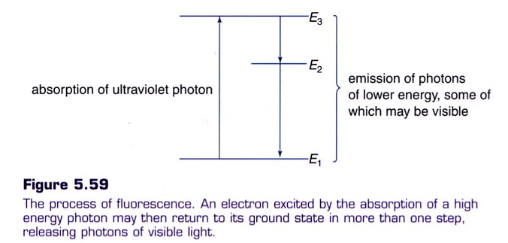

The energy of the UV photon absorbed must be exactly equal to the difference between the ground state energy and the higher energy level.

By “falling back” in two or more jumps, the energy emitted is in smaller quantities and these correspond to frequencies in the visible region.

Examples

1. Fluorescent Tube

A stream of electrons moves through a mercury vapour in the tube.

99% of the emitted energy from the Hg atoms is UV light, the rest is visible light.

This is absorbed by the white powder on the inside of the tube. It fluoresces and re-emits the
energy as visible light.

Since glass will not transmit UV radiation, the glass bulb or envelope of a fluorescent tube
will absorb the UV radiation that the fluorescent coating does not convert to visible light.
The absorbed energy will appear as heat.
2. Optical Brighteners

A practical use of this phenomenon is the addition of fluorescent "whiteners" to laundry
detergent.

These chemicals absorb ultraviolet light and re-emit the energy as blue light. Sunlight is
mainly red, orange and yellow light, giving a "yellowish" light. White colours look
"yellowish" as well as they reflect these colours.

By adding the blue light from the whiteners, the whites reflect all colours and look white.
This has the visual effect of brightening the fabric.

3. Highlighters

The substance in these pens fluoresces and gives off a characteristic colour such as green,
blue, orange, etc.

Phosphorescence

Some substances, when excited by photon absorption, form metastable states and don’t
re-emit the energy for some time. The electrons can take seconds or even hours to drop back
to their ground state so light is emitted for some time.

The process is identical to fluorescence but s called phosphorescence when there is a
significant time delay involved.

Phosphorescent substances are said to be luminous and are used in applications such as the
paint for watch dials and the coatings on television screens.

X - RAYS

An X-ray tube consists of a few basic components.

1. A heater produces electrons from the filament (called thermionic emission).

2. An electric field (produced by high voltages of about 50.0 kV or more)
accelerates electrons to very high velocities from the filament to the target.

3. Electrons decelerate rapids on hitting the target, giving some of their energy up as X-ray
(~ 5% max) and the rest as heat.

At impact, the electrons have about 5.00 x 10⁴ eV of E_{k} (calculated using W = Vq = 1/2 mv²).

The metal atoms rapidly decelerate the electrons and they lose their energy as X-ray photons and heat.

Example

Calculate the maximum frequency of an X-ray produced when an electron of 50.0 keV collides with a tungsten target and loses all of its energy as an X-ray.

When the electrons strike the target, they can lose their energy in a number of ways.

• If an electron collides with the target and stops suddenly, it loses all of its kinetic energy at
once and emits a single photon equal to the kinetic energy of the electron.

Hence, the most energetic photon that can be obtained from an X-ray tube has a kinetic
energy equal to the most energetic electrons accelerated by the accelerating voltage.

(See the above example.)

• When electrons strike the target they will typically slow down in a number of collisions with
individual atoms and lose their energy in more than one step.

Consequently, they will create a number of photons each with less energy than the maximum
possible photon energy.

This explains why X-ray spectra are continuous and have a wide range of photon energies up
to a maximum value.

Thus a stream of electrons, all with the same energy, will produce a spectrum of X-ray photons with many different frequencies.

This spectrum is called Bremsstrahlung radiation.

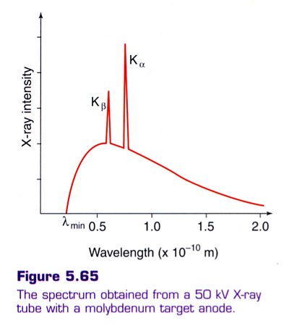

The metal target atoms will also emit a few specific X-rays due to the incoming electrons knocking inner electrons out of the atoms.

An upper energy level electron drops down to take the place of the inner electron and consequently emits a high energy X-ray photon (due to the large energy transition).

Thus, a few peaks are added to the X-ray spectrum and are characteristic for that particular metal in the target.
The presence of these peaks can be used to identify metal samples as each metal produces a characteristic “finger print” with peaks corresponding to certain wavelengths.

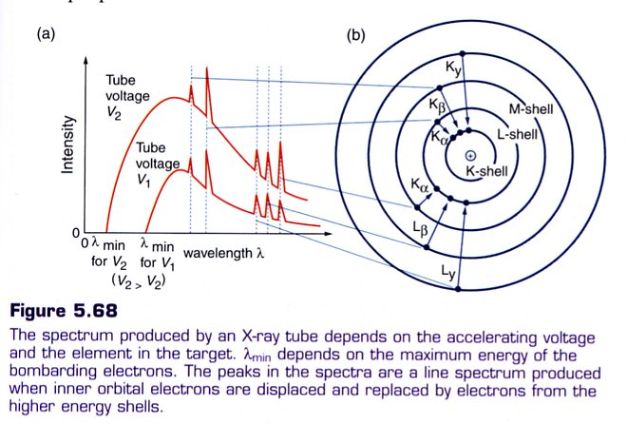

Example

